ФГБОУ ВО “УДМУРТСКИЙ ГОСУДАРСТВЕННЫЙ УНИВЕРСИТЕТ”
UDMURT STATE UNIVERSITY

Командный конкурс эссе

“Unity in Diversity: Russia and the English-Speaking World.
Time for Equal Opportunities”

Исследовательская работа (эссе)
«СТРАХИ, ТАБУ, СТРЕМЛЕНИЯ И МЕЧТЫ РОССИЙСКИХ И БРИТАНСКИХ ПОДРОСТКОВ»
«FEARS, TABOOS, AMBITIONS AND DREAMS OF RUSSIAN AND BRITISH TEENAGERS»

Участники студенты 1 курса Института истории и социологии, УдГУ (Participants 1st year students of Institute of History and Sociology, UDSU):

 | 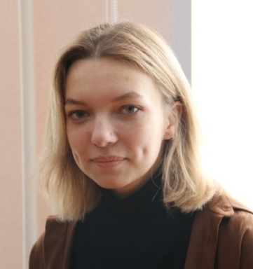 | 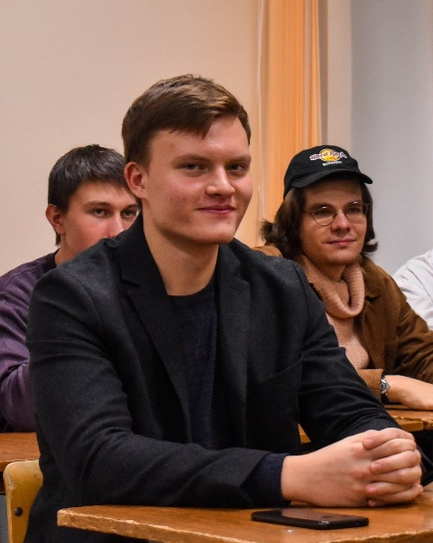
Бабкина Алина  Babkina Alina | Шилькова Анна  Shilkova Anna | Чукавин Максим  Chukavin Maxim

Руководитель: доцент кафедры иностранных языков в сфере права, экономики и управления, к.ф.н. Железнова Юлия Владимировна
Supervisor: Associate Professor of the department of foreign languages in Law, Economics and Management, candidate of philological sciences
Yulia Vladimirovna Zheleznova

Theses plan:
- Introduction.
- Fears and taboos of Russian and British teenagers.
  - What are common fears of adolescents?
  - What are particular concerns of Gen Z?
- Dreams and ambitions of Russian and British teenagers.
  - What ambitions do Russian and British teenagers tend to fulfill?
  - What do young people dream about?
- Conclusion.

Introduction
One of the main parts of the modern world is changeability. Modifications manifest themselves in new technologies, social norms, ways of communication. The external environment changes inevitably have an effect on people, especially on youngsters. Young people are more sensitive to these changes, because their personalities are only formed under the new rules of the game.
Globalization processes that have been including even the wildest places of the Earth into the post-industrial world for the last decades lead to equalization of people. Some say that this consequence is dangerous because it can destroy the institute of nationality, which means that the cultural diversity will decrease. Another point of view is that nation identity will remain and global values will focus people’s efforts on common goals achievement.
This essay is required to evaluate the equalization of people by example of Generation Z – nowadays teenagers who have born and grown during the period of globalization. The issue, authors set, is: are British and Russian teenagers mainly teenagers or nation members?
Fears and taboos of Russian and British teenagers.
From the outside it may seem that the younger generation worries only about their gadgets and internet connection, but this is totally wrong. Teenagers are still normal people and they have basic human fears like death or loneliness. But are there some fears which are specific for Generation Z?
First, we should talk about things that may alarm teens from all generations and all countries.We can't ignore the social fears of youth. According to sociologist Anna Samohvalova’s research the most pronounced fear is the fear of becoming an object of ridicule (31%). We think that this fear is connected with low self-confidence of many teenagers, and it's, actually, a big problem of the modern world, especially for girls. Today's standards of beauty are so high and unrealistic. Therefore it's hard for young people to meet them. Another one social fear is the fear of becoming a victim of bullying (42,7%). Despite the fact that the term “bullying” appeared not long ago, this phenomenon has always existed, so this fear is very relatable. Any society is characterized by some kind of hierarchy, thus occurrence of bullying particularly in peer groups, where each member is eager to approve their status, is obvious. Actually, we think that today's teenagers are more loyal and tolerant, for the reason that the topic of bullying is being discussed more and more often, so, this phenomenon ceases to be so global and the fear of being a victim of bullying is not very common. All of the above applies not only to modern teens, but also to teenagers in general, but, nevertheless, we assumed it was important to say it, because these fears are still typical for teenagers as well.
But what are Gen Z scared of? Today’s world is in a pre-catastrophic state, there are a lot of global problems, like war, terrorism, overpopulation. By all means such challenges cause anxiety among teenagers all over the world. The main fear of Generation Z is fear for the ecological state of the planet. Greta Thunberg (Appendix, Pic. 1) gave a speech that expressed the opinion of many modern teenagers. She told us about “existential crisis, more important than anything else”. In addition, fear of ecological catastrophe is really one of the main fears of teenagers. Sociologist Timophey Nestik has conducted research, according to the results of which it turned out that teenagers are most concerned about the climatological catastrophe.
Russian and British teenagers have fears related to self-realization. Today, the importance of individuality and personal success is growing, there are a lot of examples of young people who have achieved a lot, and it makes teenagers feel like they need to be very successful too. And also teenagers are scared of unemployment that would correspond to personal characteristics or would not contribute to internal development. We think that this fear is more typical for Russian teenagers, because previous generations were focused more on making money, and only now people in Russia are beginning to understand how important it is to realize yourself.
As a result, today’s teenagers face both typical teenagers’ fears and specific dreads, which make them feel anxiety. On the other hand, does the presence of social taboos affect adolescents in the same way as older generations?
First of all, there are a lot of typical social taboos. For Russian people there are a lot of “forbidden topics”, especially in conversation. The most tabooed subjects in Russia are death, religion and politics. There are no less taboos in Britain, like “dark pages” in history, and so on. We think that the main difference is that in Britain the violation of personal boundaries will also be considered as taboo. In contrast, the culture of “personal space” is not so common in Russia. But what can we say about observance of taboos by modern teenagers? We can see the diminishing importance of conversational taboos among young people. Teenagers are freer in communication with each other, but taboos about personal space and human feelings became tougher.
Among today’s youth any kind of discrimination is taboo. Teenagers are developing a culture of tolerance and personal freedom, and mentioning inequality in a negative context is unacceptable. Another one taboo, connected with previous, is prohibition on condemning people for their tastes, life choices and views. Modern teens stand for freedom of self-expression, so judging people for their choices has become a real taboo. We can also say that this phenomenon is more common in Britain, because it started developing there much earlier. Russian teenagers, in comparison with British teens, have just begun to be involved into the development of a tolerant society, and therefore the above prohibitions are not so strict for them.
To sum up we can say that almost all taboos of teens today are aimed at protecting the human personality and individuality.

Dreams and ambitions of Russian and British teenagers.
At first glance, it may seem that Russian and British teenagers are completely different and have different dreams and ambitions. But is it really so? Let us take a closer look at this issue.
Self-development is one of the main ambitions of Russian and British teenagers. They buy professional courses and intensive courses, download guides for upgrading soft skills and checklists on nutrition and psychology. Without leaving home, they can learn anything: tell the whole world about their project (YouTube, TED) and find funding for it, for example, through crowdfunding or Google Science Fair. According to Russian sociologist Natalia Freik, 84% of British and Russian teenagers believe in technology and its ability to improve the future world.
In addition, Russian and British teenagers want to make the world better. They actively participate in environmental and volunteer activities. According to the Dobro Mail.Ru survey (2017), 27% of Russian teenagers aged 13-17 are ready to “earn some money in charitable organizations”.
Due to the ambitiousness of British and Russian teenagers, they have dreams and goals quite early on. For example, the most common dreams are being successful, getting a job that brings in a lot of money, traveling the world, and learning languages. Also, many teenagers want to become famous bloggers, influencers, musicians, businessmen and so on. For example, the famous Russian figure skater Kamila Valieva (Appendix, Pic. 2) at the age of 12 already won competitions, and at 16 she became the world champion. She is an influencer, maintains her own sports blog and motivates teenagers to do sport. Another example is the popular English actor, Asa Butterfield (Appendix, Pic. 3). Since childhood, he dreamed of becoming an actor. He got his first role at the age of 9 and began his film career. After that, he became an influencer. Asa Butterfield inspires teenagers with his success and has a lot of fans all over the world.
Moreover, international experts note that another important dream of British and Russian teenagers is equality, which should apply to everyone, regardless of age. In our opinion, this is due to the fact that modern teenagers live in a continuous stream of information, learn faster and better understand how the world works. They became active participants in dialogues on current topics. For the whole Generation Z the priority is inclusiveness, equality and the opportunity to enjoy what they do in everyday life.
In general, the ambitions and dreams of modern teenagers in Britain and Russia are similar. This is due to globalization, the interaction of people on the Internet and the rapid development of technology.
Conclusion
Dichotomy of national and global values could be caused by the difference of Russian and British historical background, which determined national fears and taboos. Nevertheless, dreams and ambitions of young people are similar, because they relate to modern trends aimed at uniting. The comparison showed that the British are still British, and Russians are still Russians, but there are values in the modern world that can unite people, despite backgrounds.
REFERENCES:

- Емельянова Т.П., Нестик Т.А., Белых Т.В. ОТНОШЕНИЕ К ЭКОЛОГИЧЕСКИМ РИСКАМ СРЕДИ ПРЕДСТАВИТЕЛЕЙ ПОКОЛЕНИЙ Y И Z//Институт психологии Российской академии наук. Социальная и экономическая психология, 2019, №4.
- Самохвалова А. Г. Социальные страхи как фактор затрудненного общения городских и сельских подростков // Ярославский педагогический вестник. 2016. №2. [Электронный ресурс]. – Режим доступа: https://cyberleninka.ru/article/n/sotsialnye-strahi-kak-faktor- zatrudnennogo-obscheniya-gorodskih-i-selskih-podrostkov – Дата доступа: 30.01.2022
- Подростки готовы продавать сувениры на улице, если часть денег пойдет на благотворительность //Филантроп (Электронный журнал о благотворительности) [Электронный ресурс]. – Режим доступа: https://philanthropy.ru/novosti-organizatsij/2017/04/18/48909/ – Дата доступа: 16.01.2022
- Фреик Н.. Мечты и страхи поколения Z: к чему готовиться некоммерческому сектору?// Теплица социальных технологий (Natalia Freik. Dreams and fears of Generation Z: what should the nonprofit sector prepare for? // Journal “Greenhouse of social technologies”) [Электронный ресурс]. – Режим доступа: https://te-st.ru/2020/04/29/research-about-generation-z/ – Дата доступа: 15.01.2022

Appendix

Picture 1  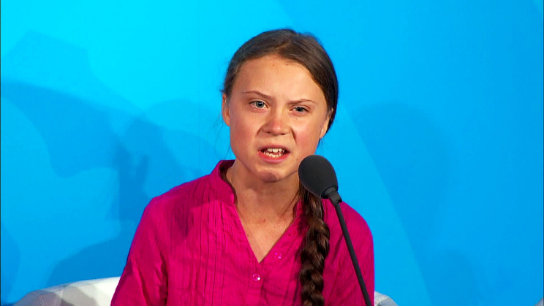 | Greta Thunberg is a Swedish environmental activist who is known for challenging world leaders to take immediate action for climate change mitigation. Thunberg initially gained notice for her youth and her straightforward and blunt speaking manner,both in public and to political leaders and assemblies, in which she criticizes world leaders for their failure to take what she considers sufficient action to address the climate crisis. Her influence on the world stage has been described by newspapers as the "Greta effect". She received numerous honours and awards, inclusion in Time's 100 most influential people, being the youngest Time Person of the Year, and nominations for the Nobel Peace Prize in 2019, 2020, and 2021.
Picture 2 | KaKamila Valieva is a Russian figure skater. She is the 2022 European champion, the 2021 Rostelecom Cup champion, the 2021 Skate Canada International champion, and the 2022 Russian national champion.  Valieva is the current world record holder for the women's short program, free skating and total scores. She is the first woman skater to break the 250- , 260- and 270- point thresholds in the total score, within one season, the first to break the 170- and 180- point thresholds in the free skate, and the first to break the 90- point thresholds in the short program.
Picture 3 | Asa Bopp Farr Butterfield is an English actor. He has received nominations for two Critics' Choice Awards, two Saturn Awards, and three Young Artist Awards.  Beginning his career as a child actor, Butterfield first achieved recognition as the lead of the historical drama film The Boy in the Striped Pyjamas (2008). He continued to headline films during the 2010s. In 2019, Butterfield began portraying the lead of the Netflix comedy-drama series Sex Education. Since 2017, Butterfield has taught an annual acting masterclass at The Reel Scene acting school in London, which covers improvisation techniques and students work on scenes from Butterfield's films.

